26.64: First recognize that if the 40  resistor is safe, all the other resistors are also safe.
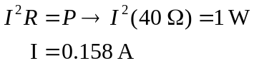
Now use series / parallel reduction to simplify the circuit. The upper parallel branch is 6.38 and the lower one is 25 . The series sum is now 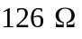. Ohm’s law gives
